HTTP GET request at /products/{id}

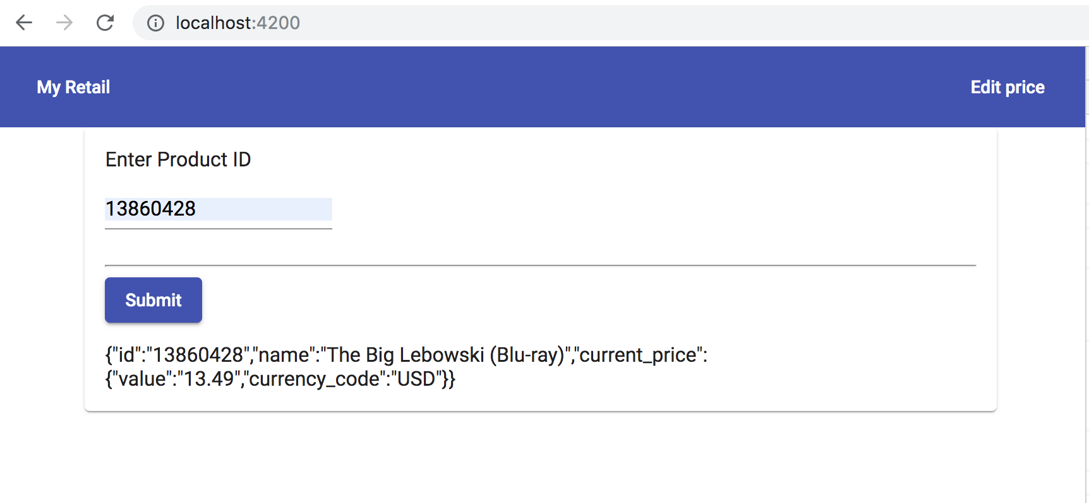

Bonus :Accepts an HTTP PUT request at the same path/products/{id}

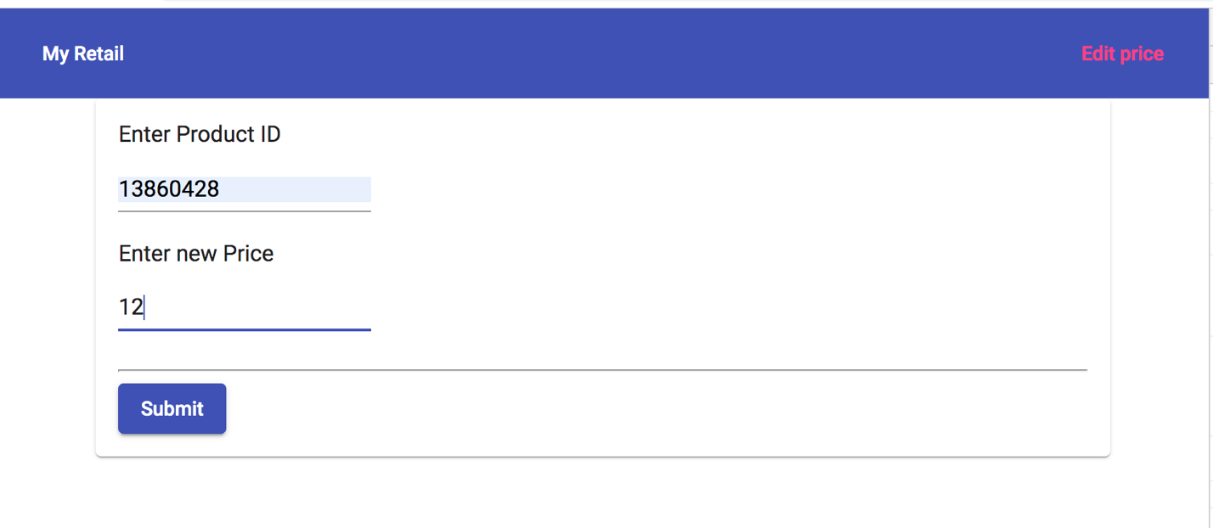

Response:

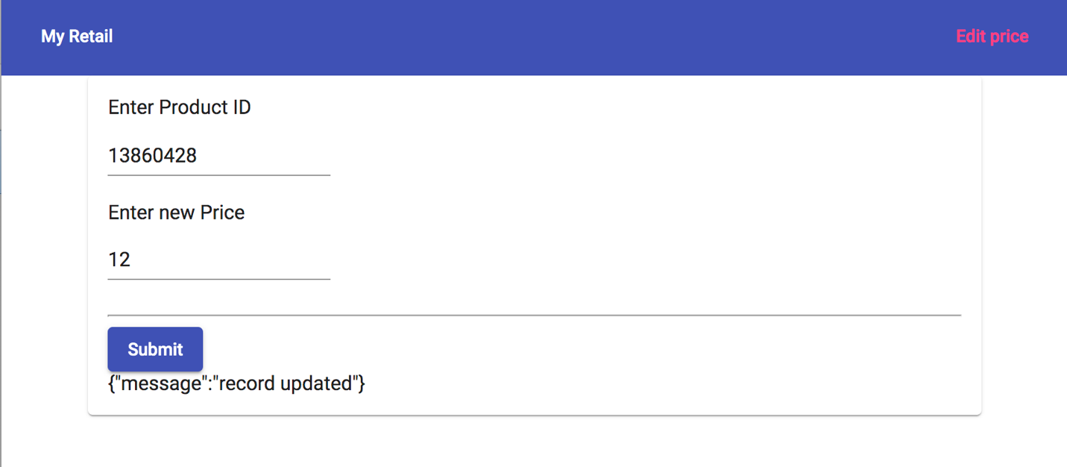

Verification:

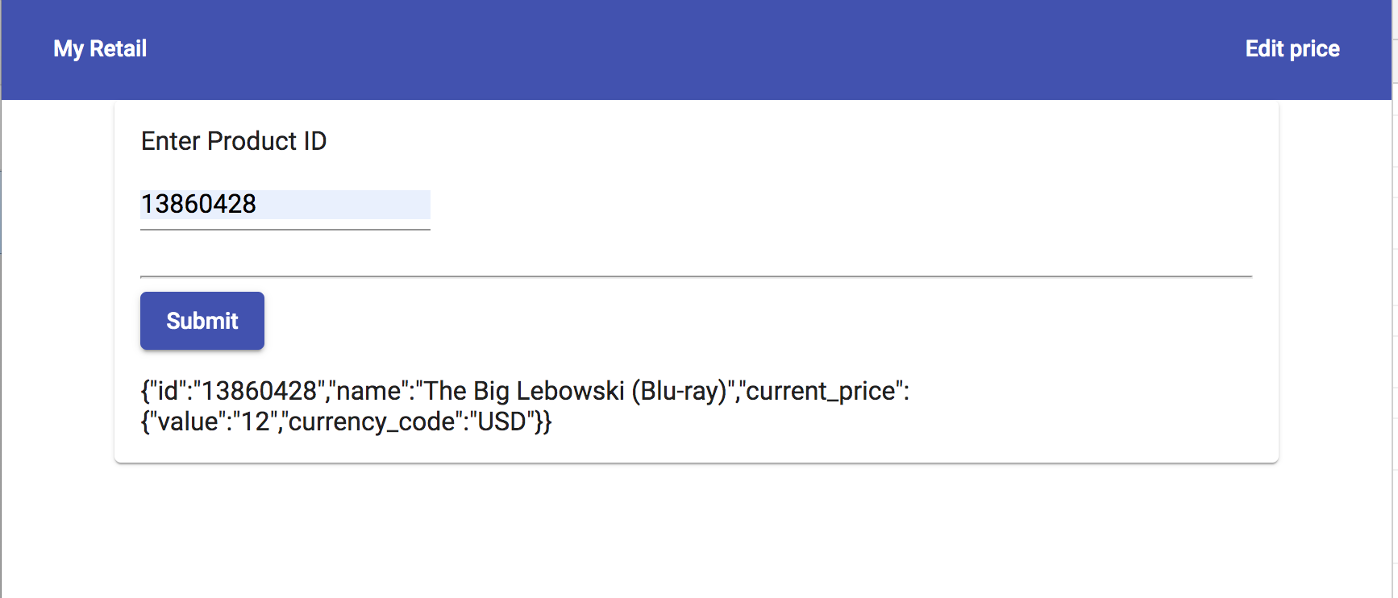

Error handling:

* ( HTTP GET)

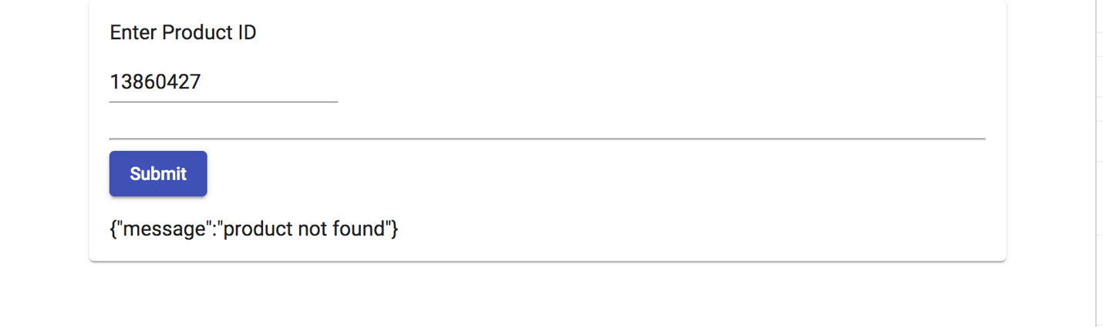

* HTTP PUT

